8DC00 Medical Image Analysis

Project 2 - CAD

Report

29-10-2021

Group 3

Aiik Biermans – 1241616

Brigitte van der Geest – 1464027

Pauline Haulez – 1462245

Willem Schellekens - 1636308

# Index

Index 2

1. Introduction 3

2. Methods 3

3. Results 3

4. Discussion 3

References 3

Appendix 3

# 1. Introduction

Computer aided diagnosis (CAD) has become standard practice for the detection of, for example, breast cancer at many screening sites and hospitals. An example of this is a CAD network which analyzes images of cell tissue and aids in the classification of these cells into malignant or benign cells. CAD is developing rapidly and has become one of the major research areas of medical imaging. (Doi, 2007)  
The size of the cell nuclei of cancer cells in the breast can be a useful feature to give a prognosis of the aggressiveness of the tumor. The bigger the nuclei the worse the prognosis. Automating the measurement of the cell nuclei saves much time in pathology workflow. The automatic classification also opens up possibilities for large scale analysis, while taking a fraction of the time when compared to manual analysis.

The goal of this project is to create a program that automates the cell nuclei measurement and classifies these cells to the large nuclei class or the small nuclei class. A prediction model for the size of the nuclei is given with the use of a linear regression model, where the calculated error of the fit of the model is evaluated. The classification is done with the use of a logistic regression model and evaluated with the outcoming accuracy. Multiple variations of parameters will be tried to find the best performing model, which is the model with the maximum accuracy and minimum loss.

Furthermore, this report will end with a comparison of these linear and logistic regression models to deep neural networks as described in the paper of Graham et al. (2019)

# 2. Methods

The used dataset, the computer-aided diagnosis methods of linear and logistic regression, and the evaluations of these methods are elaborated below.

## 2.1 Dataset

The dataset provided consists of RGB images of nuclei with size 24x24 pixels retrieved from Veta et al. (2015). The dataset involved 39 slides from patients with invasive breast cancer. The representative tumor regions of size 1x1 mm were selected by an pathologist. In the tumor regions of a size of 1x1 mm, which is a size of 4000x4000 in pixels, around 100 nuclei were manually segmented.

The dataset with 39 slides are divided in 21 slides for the training dataset with 2191 segmented nuclei. The other 18 slides are used as test dataset with 2073 segmented nuclei.

## 2.2 Linear regression

Linear regression is a method to estimate the association between a continuous dependent variable and an independent variable by fitting a linear line to the observed data. The equation of linear regression line is shown in formula 2.1. X is the independent variable and Y is the dependent variable. Due to the fitted linear line with a specific equation, for new data the outcome can be predicted.

$Y=θ^{T}X$ (2.1)

In this project, the X are the RGB images with size of 24x24 pixels of the training dataset. Each image gives an input of 24x24x3 features. The output, the dependent variable Y, is the size of the nuclei. The 300 smallest and the 300 largest nuclei are picked and visualized. Then, the resulted equation from the fitted linear line of the training data set is used to predict the areas of the nuclei in the test dataset.

## 2.3 Logistic regression

## 2.4 Methods of evaluation

Linear regression evaluation

To evaluate the result of the linear regression, the distance of every actual data point to the fitted linear regression line is calculated with the formula 2.2. The result is called the error of the linear regression model. A smaller number of the error means a better approximation of the linear regression model.

$Error=|{|Xθ-y||}_{2}^{2}$ (2.2)

The effect on the error of a smaller training dataset is also evaluated. For this evaluation only the first 5000 segmented nuclei are used instead of the full training dataset with 21910 input samples.

Logistic regression evaluation

# 3. Results

The results of the linear and logistic regressions and their evaluations, are mentioned below.

## 3.1 Linear regression

In the following figure 1 the 300 smallest and the 300 largest nuclei of the training dataset are shown.

Figure 1: The 300 smallest and 300 largest nuclei of the full training dataset

Below, figure 2 is shown. The results of the linear regression to predict the area of the nuclei in the test dataset is visualized. On the left the result of the linear regression with an input of the full training dataset of 21910 samples is shown. The error of this linear regression is 374.9.

On the right, the result of the regression with an input of only 5000 samples of the training dataset is shown. The error of this linear regression with a smaller training dataset is 744.2.   
The red line is both figures are the actual area of the test dataset on both the x axis and y axis.

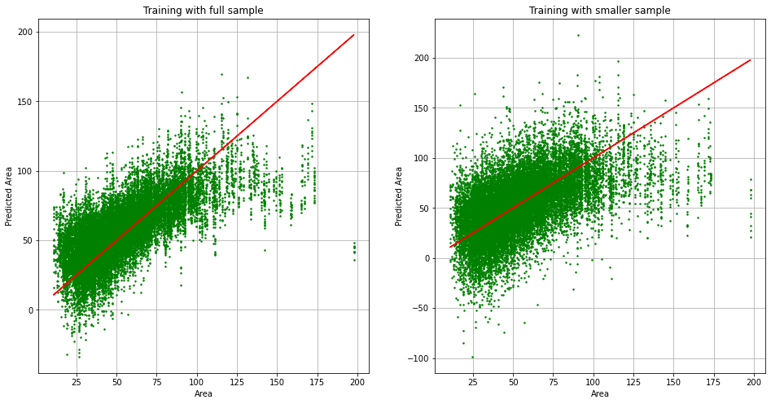

Figure 2: Predicted area versus actual area of the linear regression for the full and small training dataset

## 3.2 Logistic regression

## 3.3 Variation of hyperparameters

The figures below illustrate the effect of the learning rate on the minimization of the loss functions.

|  |  |  |
| --- | --- | --- |
| Calendar  Description automatically generated with medium confidence  Figure 3 Loss curves for | Chart  Description automatically generated  Figure 4 Loss curves for | Chart, line chart  Description automatically generated  Figure 5 Loss curves for |

Variation of the learning rate clearly shows that when the learning rate is too small, the loss function does not minimize well, as shown in Figure 3. The validation and training loss curves hardly appear the windows of the figure, which is caused by the steps of optimization of each iteration being too big. When the learning rate is too big, as in Figure 5, it takes many more iterations to reach to reach the same value in the loss functions as for a more optimal learning rate, as in Figure 4.

|  |  |  |
| --- | --- | --- |
| Chart  Description automatically generated  Figure 6 Loss curve for a batch size of 64 | Chart  Description automatically generated  Figure 7 Loss curves for a batch size of 128 | Chart  Description automatically generated  Figure 8 Loss curves for a batch size of 256 |

The effect of variation of the batch size is not very noticeable in the figures above. The loss function does reach the lowest value in the case of a batch size of 256. What is not shown in the figures is the runtime of the optimization for the three different batch sizes. A smaller batch size results in a shorter runtime, as less values have to be used in calculations.

For discussion: The lowest loss for the biggest batch size is expected, as a bigger batch size means there are more values used in the calculations of each iteration, resulting in a better prediction of the parameters for the next iteration. However, it is not expected for the validation loss to look more noisy as the batch size increases, as the prediction for the next iteration should be better. Furthermore, the shorter runtime for the smaller batch time is as expected. However, this is of less relevance for this report, as calculation times are not a main point of focus.

|  |  |
| --- | --- |
| Chart  Description automatically generated  Figure 9 Loss curves for | Chart  Description automatically generated  Figure 10 Loss curves for |

The effect of changing the initial value of is of little effect. For a value 1,000 greater, the loss curves look very similar as the parameter quickly approaches a sufficiently good value in a few iterations. The 50 first iterations are plenty for the reach this value.

# 4. Discussion

# 5. Reading assignment

The deep neural network used in Graham et al. (Graham et al.) uses a slightly modified implementation of the Preact-ResNet50 residual network (He et al, 2016) followed by three branches, each with its own function. This feature extracting network of 50 layers is then followed by branches that (1.) predicts whether a pixel belongs to the nuclei or background, (2.) predicts the horizontal and vertical gradients of the nuclei, useful for separating clustered nuclei, and (3.) determine the type of each nucleus. Altogether, this is neural network model is much more deep and complex than the models used in this report for the linear and logistic regression.

The optimization of the linear regression model is done by finding the closed-form solution for minimization of the loss function, as opposed to backwards propagation in the neural network, where the minimum is iteratively approached using the training dataset. Still, the same is done for the logistic regression model in this report. Each iteration, the parameters are adjusted until the minimum is reached, after which the minimization is ended when the improvements in the loss function start becoming insignificant. Another difference is that the linear regression model gives a prediction for the size of the nuclei, while the logistic regression network and deep neural network perform a classification in size.

The result of the complexity of the neural network used by Graham et al. is that is generalizes strongly, meaning it can be used well on data it has not been trained on. The result is that the authors claim the network would perform well on additional tissue types, even though the results follow from it being trained on only a single tissue type. This is because the network is shown to segment multiple tissues well. The strong generalization, combined with the ability to effectively segment clustered nuclei while still being computationally quick (11 seconds) means it might prove to be a useful network in the clinic.

# References

Doi, K. (2007). Computer-aided diagnosis in medical imaging: Historical review, current status and future

potential. Computerized Medical Imaging and Graphics, 31(4–5), 198–211.

<https://doi.org/10.1016/j.compmedimag.2007.02.002>

Graham, S., Vu, Q. D., Raza, S. E. A., Azam, A., Tsang, Y. W., Kwak, J. T., & Rajpoot, N. (2019).

Hover-Net: Simultaneous segmentation and classification of nuclei in multi-tissue histology images.

*Medical Image Analysis*, *58*, 101563. https://doi.org/10.1016/j.media.2019.101563

He, Kaiming, e.a. ‘Mask R-CNN’. arXiv:1703.06870 [cs], januari 2018. arXiv.org, <http://arxiv.org/abs/1703.06870>.

Veta M., van Diest P.J., Pluim J.P.W. (2016). Cutting Out the Middleman: Measuring Nuclear Area in Histopathology Slides Without Segmentation. *Medical Image Computing and Computer-Assisted Intervention;  Lecture Notes in Computer Science, vol 9901*. DOI: https://doi.org/10.1007/978-3-319-46723-8_73

# Appendix